|  |
| --- |
| GETTING STARTED |

To start things off on our Character Management System, you need a development environment for Cobalt to thrive in. This section will serve to guide you to the installation and setup of cobalt and its prerequisites and walk you through the process of starting your first Cobalt project.

**WHAT YOU NEED**

Setup and installation of a development environment for Cobalt requires the following:

* XAMPP / WAMP server
* Cobalt core files
* Your favorite IDE (Notepad++, Crimson Editor, etc)
* MySQL Workbench (this one is optional)
* A Web Browser (Firefox or Chrome is recommended)

**INSTALLING COBALT**

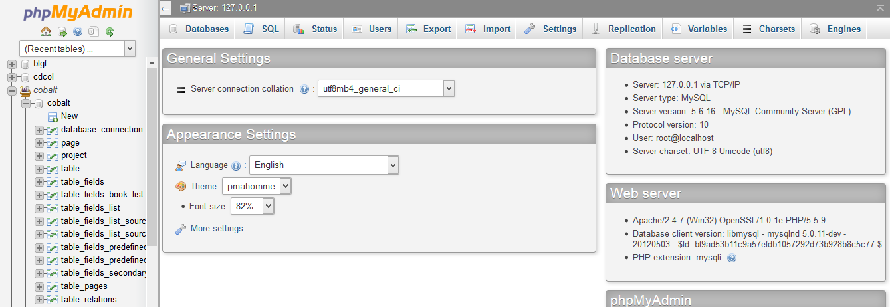Install the web server and copy / extract the cobalt core files into the web root of the web server you have chosen - /htdocs for XAMPP and /www for WAMP). Start the Apache and MySQL services and navigate to the PhpMyAdmin homepage (http://localhost/phpmyadmin).

Under the “Databases” tab, create a new database and name it “cobalt”.

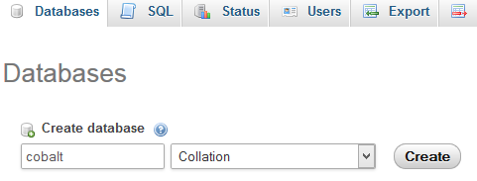

Navigate to your newly-created database. Click the “Import” tab where you will be taken to an SQL import page. Cobalt requires a few startup tables to function and these have already been included for importing in the /cobalt directory – look for the file named **cobalt.sql**.

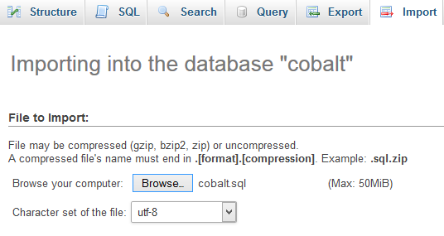

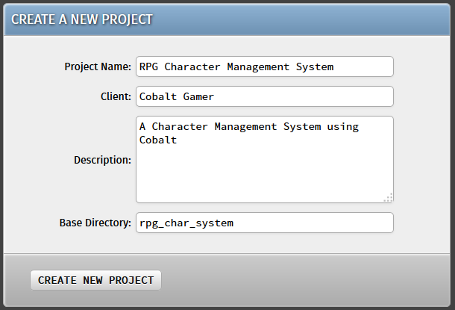Hit “Go” at the bottom of the page and wait for the script to execute. Once it is finished, the Cobalt code generator is ready for use. On a new browser tab, navigate to <http://localhost/cobalt>. From there, new projects can be created by filling in the required details on the “Create a New Project” form.

Hit the “Create New Project” button and you’re good to go! Once the project is started, you will be taken to the Cobalt Control Center where you can perform various actions on your project.

